Lab11 CIS43 Due: 7/19/2016

Name: Nikhil Vytla

***Exercise: Ex 12.8, 12.9, and 12.12***

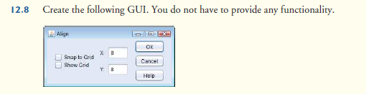

SecondGui

**package** P128;

**import** java.awt.BorderLayout;

**import** java.awt.GridLayout;

**import** javax.swing.JCheckBox;

**import** javax.swing.JFrame;

**import** javax.swing.JButton;

**import** javax.swing.JLabel;

**import** javax.swing.JPanel;

**import** javax.swing.JTextField;

**public** **class** SecondGui **extends** JFrame{

**public** SecondGui()

{

doThings();

}

JButton b1;

JButton b2;

JButton b3;

JCheckBox cb1;

JCheckBox cb2;

JLabel lab1;

JLabel lab2;

JTextField tf1;

JTextField tf2;

**private** **void** doThings()

{

JPanel paper1;

paper1 = **new** JPanel();

JPanel paper2;

paper2 = **new** JPanel();

JPanel paper3;

paper3 = **new** JPanel();

JPanel paper2plus;

paper2plus = **new** JPanel();

paper1.setLayout(**new** GridLayout(2,1));

paper2.setLayout(**new** GridLayout(2,1));

paper3.setLayout(**new** GridLayout(3,1));

cb1 = **new** JCheckBox("Snap to Grid");

cb2 = **new** JCheckBox("Show Grid");

lab1 = **new** JLabel("X:");

lab2 = **new** JLabel("Y:");

tf1 = **new** JTextField(10);

tf2 = **new** JTextField(10);

b1 = **new** JButton("Ok");

b2 = **new** JButton("Cancel");

b3 = **new** JButton("Help");

paper1.add(cb1);

paper1.add(cb2);

paper2.add(lab1);

paper2.add(tf1);

paper2.add(lab2);

paper2.add(tf2);

paper3.add(b1);

paper3.add(b2);

paper3.add(b3);

add(paper1, BorderLayout.*WEST*);

add(paper2, BorderLayout.*CENTER*);

add(paper3, BorderLayout.*EAST*);

}

}

-------------------------------------------------

Mainz

**package** P128;

**import** javax.swing.JFrame;

**public** **class** Mainz {

**public** **static** **void** main(String[] args) {

SecondGui fg = **new** SecondGui();

fg.setSize(350,100);

fg.setDefaultCloseOperation(JFrame.*EXIT_ON_CLOSE*);

fg.setVisible(**true**);

}

}

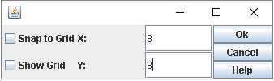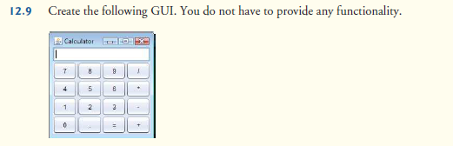

FirstGui

**package** P129;

**import** java.awt.BorderLayout;

**import** java.awt.GridLayout;

**import** javax.swing.JFrame;

**import** javax.swing.JButton;

**import** javax.swing.JPanel;

**import** javax.swing.JTextField;

**public** **class** FirstGui **extends** JFrame{

**public** FirstGui()

{

doThings();

}

JButton b1;

JButton b2;

JButton b3;

JButton b4;

JButton b5;

JButton b6;

JButton b7;

JButton b8;

JButton b9;

JButton b10;

JButton b11;

JButton b12;

JButton b13;

JButton b14;

JButton b15;

JButton b16;

JTextField tf1;

**private** **void** doThings()

{

JPanel paper;

paper = **new** JPanel();

paper.setLayout(**new** GridLayout(4,4));

tf1 = **new** JTextField(10);

b1 = **new** JButton("7");

b2 = **new** JButton("8");

b3 = **new** JButton("9");

b4 = **new** JButton("/");

b5 = **new** JButton("4");

b6 = **new** JButton("5");

b7 = **new** JButton("6");

b8 = **new** JButton("*");

b9 = **new** JButton("1");

b10 = **new** JButton("2");

b11 = **new** JButton("3");

b12 = **new** JButton("-");

b13 = **new** JButton("0");

b14 = **new** JButton(".");

b15 = **new** JButton("=");

b16 = **new** JButton("+");

paper.add(b1);

paper.add(b2);

paper.add(b3);

paper.add(b4);

paper.add(b5);

paper.add(b6);

paper.add(b7);

paper.add(b8);

paper.add(b9);

paper.add(b10);

paper.add(b11);

paper.add(b12);

paper.add(b13);

paper.add(b14);

paper.add(b15);

paper.add(b16);

add(paper, BorderLayout.*CENTER*);

add(tf1, BorderLayout.*NORTH*);

}

}

-------------------------------------------------

Main

**package** P129;

**import** javax.swing.JFrame;

**public** **class** Main {

**public** **static** **void** main(String[] args) {

FirstGui fg = **new** FirstGui();

fg.setSize(300,400);

fg.setDefaultCloseOperation(JFrame.*EXIT_ON_CLOSE*);

fg.setVisible(**true**);

}

}

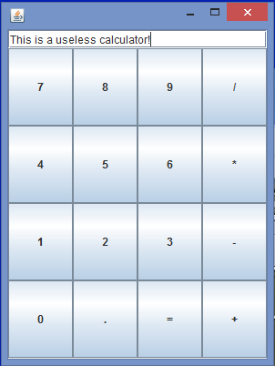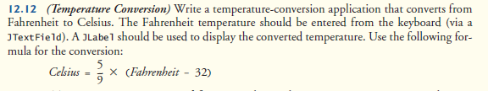

Gui2

**package** P1212;

**import** java.awt.BorderLayout;

**import** java.awt.GridLayout;

**import** java.awt.event.ActionEvent;

**import** java.awt.event.ActionListener;

**import** javax.swing.JFrame;

**import** javax.swing.JButton;

**import** javax.swing.JLabel;

**import** javax.swing.JPanel;

**import** javax.swing.JTextField;

**public** **class** Gui2 **extends** JFrame{

**public** Gui2()

{

doThings();

}

JButton b1;

JButton b2;

JButton b3;

JTextField tf1;

JTextField tf2;

JTextField tf3;

JLabel lab1;

JLabel lab2;

**private** **void** doThings()

{

JPanel paper1;

paper1 = **new** JPanel();

JPanel paper2;

paper2 = **new** JPanel();

paper1.setLayout(**new** GridLayout(2,2));

paper2.setLayout(**new** GridLayout(1,2));

tf1 = **new** JTextField(10);

tf2 = **new** JTextField(10);

b1 = **new** JButton("CONVERT");

b2 = **new** JButton("CLEAR");

lab1 = **new** JLabel("Fahrenheit");

lab2 = **new** JLabel("Celsius");

paper2.add(b1);

paper2.add(b2);

paper1.add(lab1);

paper1.add(tf1);

paper1.add(lab2);

paper1.add(tf2);

add(paper1, BorderLayout.*NORTH*);

add(paper2, BorderLayout.*SOUTH*);

Bh1 bh1 = **new** Bh1();

b1.addActionListener(bh1);

Bh2 bh2 = **new** Bh2();

b2.addActionListener(bh2);

}

**class** Bh1 **implements** ActionListener

{

**public** **void** actionPerformed(ActionEvent event)

{

String s1 = tf1.getText();

**double** f = Double.*parseDouble*(s1);

**double** c = 5.0 / 9.0 * (f - 32);

tf2.setText(Double.*toString*(c));

}

}

**class** Bh2 **implements** ActionListener

{

**public** **void** actionPerformed(ActionEvent event)

{

tf1.setText("");

tf2.setText("");

}

}

}

Main2

**package** P1212;

**import** javax.swing.JFrame;

**public** **class** Main2 {

**public** **static** **void** main(String[] args) {

Gui2 fg = **new** Gui2();

fg.setSize(300,400);

fg.setDefaultCloseOperation(JFrame.*EXIT_ON_CLOSE*);

fg.setVisible(**true**);

}

}

